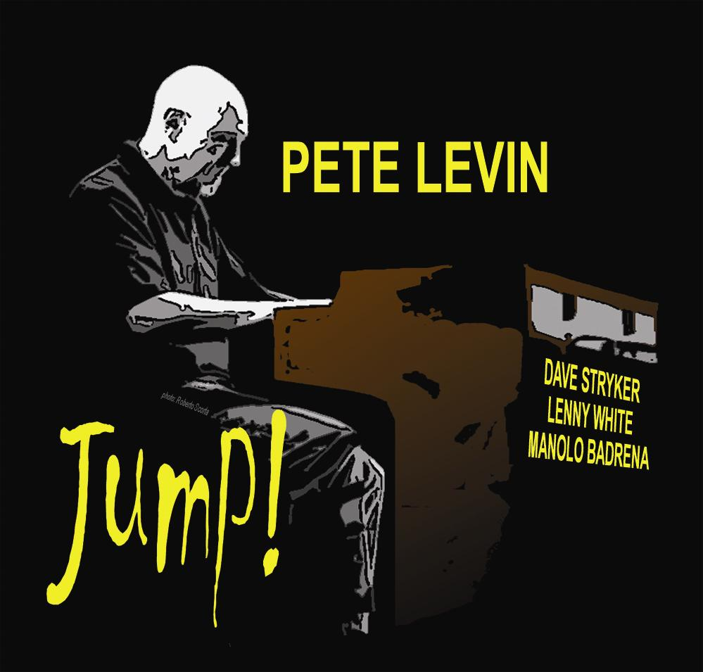
Michael Bloom Media Relations
P.O. Box 41380 Los Angeles, CA 90041
contact: Michael Bloom
tel: 323.258.6342 email: musicpr@earthlink.com

PETE LEVIN
Jump!
Pete Levin Music

Sept 22 Release Date

Pete Levin’s 2010 CD release JUMP! documents his continuing efforts to push the envelope of the traditional organ trio. The set is a collaboration with the remarkable guitarist Dave Stryker and legendary drummer Lenny White. They are joined on 5 of the 10 tracks by the dazzling percussionist Manolo Badrena. Pete knows how to feature his sidemen, but when it’s time for the Hammond to take charge, he does just that. In addition, the organ’s bass is mixed up front as an equal element. This is not your father’s organ trio! The set rocks and grooves hard - not a hint of smooth jazz within earshot.

In a diverse music career spanning three decades, the New York based keyboardist/arranger has performed and recorded with hundreds of jazz and pop artists - including Paul Simon, Annie Lennox, Miles Davis, David Sanborn, Lenny White, Wayne Shorter, Jaco Pastorius, Robbie Robertson and John Scofield - receiving critical accolades for his work during a 15-year association with the legendary Gil Evans, and his 8-year stint with the late Jimmy Giuffre.

While filling the French Horn chair with the Gil Evans Orchestra in the 70s, Levin brought a Moog Synthesizer to a gig at New York's Village Vanguard. Already known as a synthesizer specialist, Pete was at the vanguard of that technology. Levin's role was permanently changed as the band transformed itself into the electric/acoustic hybrid ensemble that captivated audiences worldwide for years, winning two Grammy awards along the way.

A veteran session and live keyboardist, Levin has also created electronic realizations for hundreds of TV commercials, dramatic series and feature films, including MISSING IN ACTION, LEAN ON ME, SILVER BULLET, RED SCORPION, THE COLOR OF MONEY, MANIAC, SPIN CITY, AMERICA'S MOST WANTED and STAR TREK. In a dizzying array of unrelated commissions, Levin composed orchestral scores for the feature film ZELIMO and for a stage production of THE DYBBUK, composed the anthem for the 1992 United Nations Earth summit, THE FUTURE IS IN OUR HANDS, performing it twice for the General Assembly, and created the official military band arrangement of the U.S. Infantry song.

But Levin, whose wry sense of humor is never far from the surface, reveals that his all time favorite recording session produced the top-40 hit single CLOSE TO YOU by THE CLAMS, a Spike Jones tribute band formed with his brother, bassist Tony Levin (Peter Gabriel, King Crimson), drummer Steve Gadd (Eric Clapton, Paul Simon) and Grammy-awarded recording engineer Dixon Van Winkle (Paul McCartney, Frank Sinatra). Thirty years later the recording is still a cult classic.

In 1990, Levin signed with Gramavision to release his first solo jazz album, PARTY IN THE BASEMENT, followed by SOLITARY MAN in 1991. Collaborating with drummer Danny Gottlieb, Pete released THE NEW AGE OF CHRISTMAS on Atlantic and MASTERS IN THIS HALL for Gramavision. In the years following, he released six solo and collaboration albums for Alternate Mode Productions.

In 2007, Pete decided to revisit his roots and his favorite keyboard instrument, the Hammond B-3 Organ, releasing DEACON BLUES on the Motéma label. He’d been playing a Hammond B-3 for years, but had never recorded as a leader in the organ trio format.

In 2008, Levin released another trio album, CERTIFIED ORGANIC, in which Pete’s original compositions explored the bonds between jazz and funk: dark music with hard-driving grooves. The set also included two of his straight-ahead pieces, with guitarist Mike DeMicco joining him for “When I Was Young”, a tune they played together with the Brubeck Brothers Quartet, and Joe Beck sitting in for “The Face in the Mirror”, which Pete wrote for (and recorded with) trumpeter Lew Soloff.

Which brings us to Levin’s new album, JUMP!. In addition to Pete’s great originals, the set includes some jazz classics, such as Charles Mingus' "Nostalgia In Times Square" and Freddie Hubbard’s "Little Sunflower" (done in 7/4).

The final track on JUMP! is a tribute to the late Joe Beck. Pete and Joe recorded "Honeysuckle Rose" as a duet years ago, but it was never used on an album. Pete retrieved the original tracks and added Danny Gottlieb on drums. The three had played many trio gigs in the past, so this is a poignant reunion.

Pete currently tours with a high-energy organ trio with guitarist Dave Stryker and drummer Lenny White

www.petelevin.com

